Template for bachelor and master theses in audiology at SDU

Bachelor/Master thesis in Audiology

Student: Georg Gearløs
Examination number: 012345678

Primary supervisor: Andersine And
Secondary supervisor: Anders And

Date: XX.YY.20ZZ

Table of Contents
Table of Contents I
Abstract III
Resumé IV
List of Acronyms V
List of Figures/Tables VI
1 Introduction 1
1.1 Sub-section 1 1
1.1.1 Sub-section 2 1
1.1.2 Number of pages 1
1.1.3 Language 2
1.1.4 Citations 2
2 Methods and Materials 3
2.1 Participants 3
2.2 Hearing aid fittings 3
2.3 Test setup 3
2.4 Measurements 3
2.4.1 Speech reception thresholds 3
2.4.2 Distortion-product oto-acoustic emissions 4
2.5 Test protocol 4
2.6 Statistical analyses 4
3 Results 5
3.1 Speech reception thresholds 5
3.2 Distortion-product oto-acoustic emissions 6
4 Discussion and Conclusions 7
References 8
Appendix A 9
Appendix B 10
Title page 10
Numbered headings 10
Large unnumbered hearings (e.g. Abstract, References…) 10
Flow text 10
Captions for tables and figures 10
Text in tables 11
Figures and equations 11
Page numbers 11
Section headers 11
Acknowledgements 12
Declaration of Authorship 13

Abstract
The purpose of the abstract is to give a short and precise summary of your investigation. For a bachelor thesis, the abstract may fill up to one page of text (ca. 300 words). Start with 1-2 sentences that provide relevant background information (e.g. about an aspect that is currently unclear or of particular interest in audiology). Next, specify the purpose of your investigation (which was typically to address the aforementioned aspect). Then move on to the methods and materials that you used (ca. 2-4 sentences), followed by a summary of your main findings (ca. 2-3 sentences). Finally, state the main conclusions (ca. 1-2 sentences). If you have some space left, you can add a sentence that provides an outlook (i.e. what would be the logical or necessary next steps to take).
For a master thesis, the abstract may be longer (2-3 pages). However, we encourage you to keep it as short as possible (a reader typically does not want to read several pages of text to get an idea of what your project is about!). Our recommendation is around 400 words.
The abstract needs to be written in passive voice (e.g. “Measurements were performed…” rather than “I/we performed measurements…”). Furthermore, it should not contain any citations or references. In general, use neutral language throughout your thesis, i.e. avoid colloquial, colourful and emotional formulations.
It is not easy to write a good, precise abstract! In general, it is a good idea to write the abstract at the end when you know the ‘story’ for the rest of your thesis.

Resumé
No matter whether you write your thesis in Danish or not, there needs to be a resumé in Danish. There also needs to be an abstract in another language. In general, this should be English. If you for some reason want to write it in another language, you must obtain permission from your supervisor to do so in advance.
If you write your thesis in Danish, place the resumé before the abstract. If you write your thesis in English, it makes more sense to have the abstract before the resumé.
The requirements for the resumé are otherwise identical to those specified above for the abstract.

List of Acronyms
HL: Hearing level
DPOAE: Distortion-product oto-acoustic emission
SPL: Sound pressure level
SRT: Speech reception threshold
…

List of Figures/Tables
When there are many figures or tables, it can make sense to make a list of them, too. However, this is not a requirement.

Introduction
The purpose of the introduction is to familiarize the reader with the area of the investigation in general, and to provide detailed background information that is directly relevant for it. Typically, the introduction starts with a paragraph that provides a general overview to the field. In the following paragraphs, it then goes into more depth and provides a summary of the relevant literature. In other words, you have to demonstrate here that you have made an effort to find out what is already known about your chosen topic and give credit to this work by summarizing and citing it appropriately! The introduction typically ends with a paragraph that summarizes the purpose of the investigation. In the case of an empirical study, it typically specifies any problem formulations or hypotheses that you postulated (i.e. based on your review of previous literature findings, what did you expect to find in your study?).
It is not easy to write a good introduction! In general, it is a good idea to complete the introduction at the end when you know the ‘story’ for the rest of your thesis. In this manner, you can make sure that there is a good ‘flow’ in your writing.

Sub-section 1
Sub-sections may help to structure the introduction (and the following chapters) better. In general, this can help to improve readability. In the introduction, there could for example be a sub-section titled “Background theory” and another one titled “Problem formulation” or “Hypotheses”.

Sub-section 2
If needed, a second sub-section level may be used. For example, it can make sense to split up the “Background theory” into smaller sub-sections. However, make sure that you do not end up with many very short sub-sections!

Number of pages
For a bachelor thesis, there should be 22-26 pages (per student) for the main part of your thesis, i.e. the Introduction, Methods and Materials, Results, Discussion and Conclusions chapters – the title page, table of contents, list of acronyms, list of figures/tables, references, appendices, acknowledgments etc. do not count! For a master thesis, there should be 60-80 pages (per student) for the main part of your thesis. For a “projektorienteret forløbsopgave”, there should be 5-7 pages (per student). For more detailed information about the number of pages, characters per page etc., please consult the “studieordningen” of your course.

Language
You can write your thesis in Danish or English. A thesis in English can potentially reach a wider audience, though.
Unlike the abstract and resumé, the remainder of the thesis can be written in active voice (e.g. “We performed the measurements…”). However, passive voice is also possible. Just make sure you are consistent in your use of language.
Remember also to proofread your thesis carefully. If possible, ask somebody else to do this for you. Note also that MS Word has a built-in spellchecker ( Review Spelling & Grammar). The language for this can be set under Review Language.

Citations
It is very important that you cite previous work correctly and completely – always remember that plagiarism is the greatest sin you can commit in academic writing! Identify direct quotes as such by using double citation marks around the citation (“…”). If referring to a publication in the text, use the following convention:
In a recent study, the influence of the stimulus presentation level on auditory brainstem responses was investigated (Andersen et al., 2009).
Alternatively, if you want to name the authors explicitly in the text, use the following convention:
In a recent study, Andersen et al. (2009) investigated the influence of stimulus presentation level on auditory brainstem responses.
Note that there is professional software available at SDU for managing references and citations (e.g. EndNote), but it takes time getting used to it. Our recommendation is that students start using it for their Master projects.

Methods and Materials
This section contains all the details about the methods and materials that you used for your study. The examples given below are representative for an empirical investigation. In case you performed a literature study, you would present the theoretical methods that you used (e.g. literature search) here instead.
Typically, this section is the easiest to write, so you probably want to start here.

Participants
In the case of an empirical study, this section contains all the information about your participants.

Hearing aid fittings
In the case of a project about hearing aids, you need to specify the hearing aids that you used, how you fitted them etc.

Test setup
A description of your physical test setup (e.g. the test environment, hardware, software…) is always a good idea.

Measurements
Typically, there is a sub-section detailing all the measurements that you made, e.g. speech reception thresholds or oto-acoustic emissions.

Speech reception thresholds
If you have any equations to specify, use MS Word’s built-in function for creating them ( Insert Equation). Equations should be numbered consecutively. Here’s an example:
Equation 1 specifies the logistic function that was used for fitting the data from the speech reception measurements:
$f\left(x\right)=\frac{1}{1+e^{-x}}$ (1)

Distortion-product oto-acoustic emissions

Test protocol
Sometimes it can make sense to have a sub-section about your test protocol (e.g. how many visits were there, what was their duration, which measurements were performed when…).

Statistical analyses
If you have anything to say about how you analysed your data in general, then it makes sense to have a sub-section for this.

Results
This section contains all your results. These are typically presented in tables and figures. Tables and figures must be numbered, and there needs to be a caption for each table and figure that summarizes its contents (based on the information given in the caption, the reader needs to be able to understand what is presented in the table/figure). You can use MS Word’s built-in caption function for this ( References Insert Caption Label: Table or Figure); this will take care of the numbering for you.
It is very important that you present your results in a clear fashion, so that the reader can get a good overview of them! Always remember to specify the units of your measurements and clearly label all axes, legends etc. In the text, describe your results in as neutral as possible a way (i.e. do not discuss them in this section).
Typically, this section is also relatively easy to write.

Speech reception thresholds
Here is an example for which cross-references were used to keep track of the numbering ( Insert Cross-reference Reference type: Table Insert reference to: Only table and number):
Table 1 summarizes the results from the SRT measurements.

 | SRT (dB SNR)
 | Condition 1 | Condition 2 | Condition 3
Group 1 | -5.0  (-6.3, -2.1) | -4.2  (-7.1, -3.1) | -4.6  (-6.8, -3.5)
Group 2 | -3.5  (-6.6, -1.9) | -3.0  (-6.4, -3.0) | -5.0  (-7.3, -3.1)
Table 1: Mean SRT measurements for the two groups of participants and three test conditions. Data in parentheses correspond to minimal and maximal values.

Distortion-product oto-acoustic emissions
Here’s an example of a figure (again, cross-references were used):
Figure 1 shows an example OAE measurement.

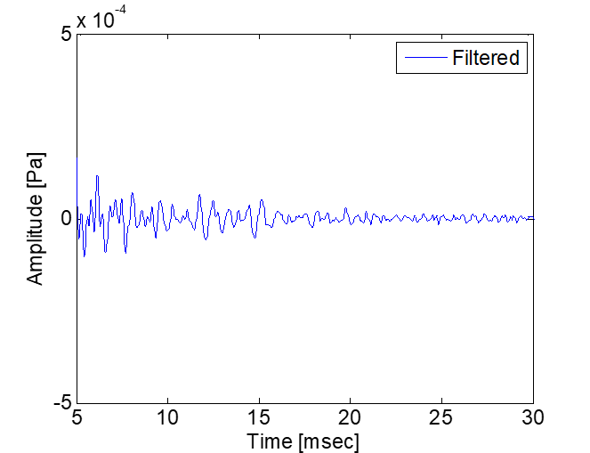
Figure 1: Example oto-acoustic emission measurement (in Pascal) as a function of time (in milliseconds). In this case, the filtered recording is displayed, as indicated in the figure.

Discussion and Conclusions
In general, it is a good idea to start this section with a summary of what you did and what you found out. This can then lead nicely over to a discussion of any interesting (expected or unexpected) aspects. Think about the purpose and/or hypotheses of your investigation. Was the purpose achieved? If no, what could be the reasons for this? Did you obtain results consistent with your hypotheses? If yes, what are the possible consequences, e.g. for clinical practice? If no, what could be the reasons for this?
Based on your discussion of the above aspects, you then need to come to some conclusions and state these explicitly. Are there any clear limitations that prevent you from drawing firm conclusions? (There typically always are some.) Then you should also acknowledge and discuss them. By doing so, you can demonstrate that you have a good grasp of your area of investigation, and you provide input for follow-up work as well. What would be the logical next steps to take? Which aspects would be interesting to investigate further?
Typically, this section is a bit harder to write because you need to evaluate your own work carefully in light of previous relevant findings. Based on this evaluation, you then need to draw conclusions that are supported by your findings.
Sometimes, it is preferable to have separate chapters for the discussion and conclusions. This is a matter of personal taste. The important thing is that both are aspects covered in your thesis and that the structure is clear.

References
The examples below illustrate how you should present and format your references. The references should appear in alphabetical order. If there is more than one reference from the same author(s), start with the newest publication and add ‘a’, ‘b’, ‘c’… to the year of publication (e.g. 2011a, 2011b, 2011c). A program like EndNote will do all of this for you automatically.

Journal articles:
Cameron, S. & Dillon H. (2008). “The listening in spatialized noise-sentences test (LISN-S): Test-retest reliability study”, International Journal of Audiology, 46 (3), 145-153
Gatehouse, S. (1989). “Apparent auditory deprivation effects of late onset: The role of presentation level”, Journal of the Acoustical Society of America, 86 (6), 2103-2106
Kemp, D. T., Ryan, S. & Bray, P. (1990). “A guide to the effective use of otoacoustic emissions”, Ear & Hearing, 11 (2), 93-105

Books:
Moore, B. C. J. (1998). Cochlear Hearing Loss. Whurr Publishers, London, UK

Book chapters:
Baran, J. A. (2007). “Test battery considerations”, in: F. E. Musiek & G. D. Chermak (Eds.) Handbook of (Central) Auditory Processing Disorders. Vol. I. Auditory Neuroscience and Diagnosis. Plural Publishing, San Diego, CA, 163-192.

Appendix A
Appendices are useful for presenting ancillary information that would disturb the flow of the main text. For example, you may want to put a questionnaire here that you used for your study. Or you may want to include the individual data from all your participants (e.g. in a table). Another example could be written instructions that you gave to your participants or a graphical user interface used for the data collection (see below).
Figure 2 shows the graphical user interface that was used for the psychoacoustic measurements.

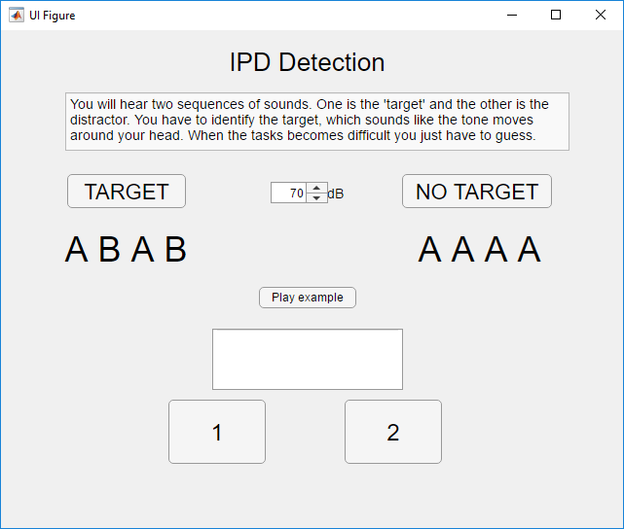
Figure 2: Graphical user interface used for the psychoacoustic measurements.

Appendix B
This appendix specifies the layout that we used for the template above. For visual consistency with other theses from SDU, we would like you to adopt this.

Order of chapters/sections
The general order of chapters and sections should be as in this template (title page, table of contents, abstract/resumé, list of acronyms, list of figures/tables, introduction, methods and materials, results, discussion and conclusions, references, appendices, acknowledgments, declaration of authorship).

Title page
SDU logo: In top right-hand corner
Title: Arial, 24 pt, bold, left justified, 18 pt spacing before and after
Other text: Arial, 14 pt, plain, left justified, 18 pt spacing before and after

Table of contents
The layout of the table of contents should be as in this template. Unfortunately, when you update the table of contents to reflect any changes that you made to the structure and headings of your thesis, MS Word reformats it as per the original style. So before you finalize your thesis, you need to reformat it (there does not seem to be a more elegant way). To do so, select all the text in the table of contents (except for the heading) and change the font back to Times New Roman, 12 pt. Also, change the first line indentation of the text back to 0 cm. You can do this either by going to Home Paragraph Indentation Special First line 0 cm, or by manually moving the little arrow on the ruler above the document to 0 cm.

Numbered headings
First level: Arial, 20 pt bold, 18 pt before, 12 pt spacing after, left justified
Second level: Arial, 16 pt bold, 0 pt spacing before, 6 pt spacing after, left justified
Third level: Arial, 14 pt plain, 0 pt spacing before, 6 pt spacing after, left justified

Large unnumbered hearings (e.g. Abstract, References…)
Arial, 20 pt bold, left justified, 18 pt spacing before and after

Flow text
Times New Roman, 12 pt plain, justified, line spacing of 1.5 lines, 1.5 cm indentation at the beginning of a paragraph, 0 pt spacing before and 6 pt spacing after each paragraph

Captions for tables and figures
Times New Roman, 12 pt italics, centred, single line spacing

Text in tables
Times New Roman, 12 pt plain or bold, centred, single line spacing, 6 pt spacing before and after

Figures and equations
Numbered and centred

Page numbers
No page number on the title page, afterwards large Roman numerals until the start of the main document (i.e. the introduction). Then Arabic numerals until the end of the thesis. All page numbers should appear at the bottom of a page and be centred.

Section headers
The chapters in the main document (Introduction, Methods and Materials, Results, Discussion and Conclusions) should have corresponding headers (Times New Roman, 12 pt, italics) in the top right-hand corner (e.g. “1. Introduction”).

Acknowledgements
Acknowledge any help that you got from colleagues, friends… If you want to, you can also thank your participants, supervisors, parents, goldfish…

Declaration of Authorship
It is essential that you fulfil all formal requirements for your thesis and that you explicitly state that this was the case. You do this by including and signing the following statement in your thesis. If you reused material from another course (e.g. the “projektorienteret forløb”), you must explicitly say so (otherwise, you can delete the concerned sentence from the text below).

I hereby confirm that I authored this thesis independently, and that I did not use any sources or aids other than those specified in the text. I hereby also point out that the introduction of this thesis is largely based on a report I wrote for another course (“Projektorienteret forløb”) with the title “……………”. Finally, I confirm that when producing this thesis I adhered to the principles of good scientific practice of the University of Southern Denmark.

___________________________________________________________________________
Date, name, signature

